Sometimes we don’t want to get a new HTML page on each requests. Sometimes we only want to exchange data with the server without reloading the page.

**What are Async Requests?**

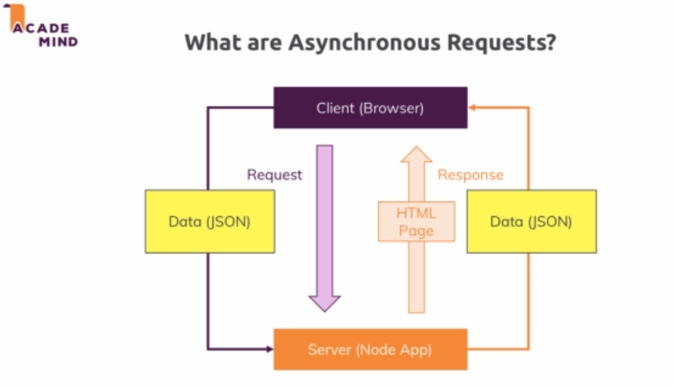

**Adding Client-Side Javascript**

<input type="hidden" value="<%= product._id %>" name="productId">

<input type="hidden" name="_csrf" value="<%= csrfToken %>">

<button class="btn" type="button" onclick="deleteProduct(this)">

    Delete

</button>

const deleteProduct = (btn) => {

    const prodId = btn.parentNode.querySelector('[name=productId]').value;

    const csrf = btn.parentNode.querySelector('[name=_csrf]').value;

const productElement = btn.closest('article');

    fetch('/admin/product/'+prodId, {

        method: 'DELETE',

        headers: {

            'csrf-token': csrf

        }

    })

    .then(result => {

        return result.json();

    })

    .then(data => {

        console.log(data);

        productElement.parentNode.removeChild(productElement);

    })

    .catch(err => {

        console.error(err);

    })

}

**What is JSON?**

JSON stands for ****J****ava****S****cript ****O****bject ****N****otation and a typically JSON data structure looks like this:

{

"name": "Your Name",

"age": 29,

"courses": [

"angular-the-complete-guide",

"react-the-complete-guide"

],

"profile": {

"joined": "2017-05-21",

"courses": 2

},

"averageRating": 4.8,

"active": true

}

It looks a lot like a normal JavaScript object, but one important difference is that all key names are enclosed by double quotation marks (").

Besides that, you can store text (string), numeric (integers and floats) and boolean data as well as nested objects and arrays.

You can dive deeper on this page: [https://www.json.org/](https://www.json.org/" \t "https://www.udemy.com/course/nodejs-the-complete-guide/learn/lecture/_blank)

**Useful resources:**

More on the fetch API: [https://developers.google.com/web/updates/2015/03/introduction-to-fetch](https://developers.google.com/web/updates/2015/03/introduction-to-fetch" \t "https://www.udemy.com/course/nodejs-the-complete-guide/learn/lecture/_blank)